Comp 3500 – Homework 2

GROUP 13

John Carroll

RayShawn Ware

Bethany Edgar

Individual Answers:  
John Carroll  
COMP 3500 – Group Homework 2

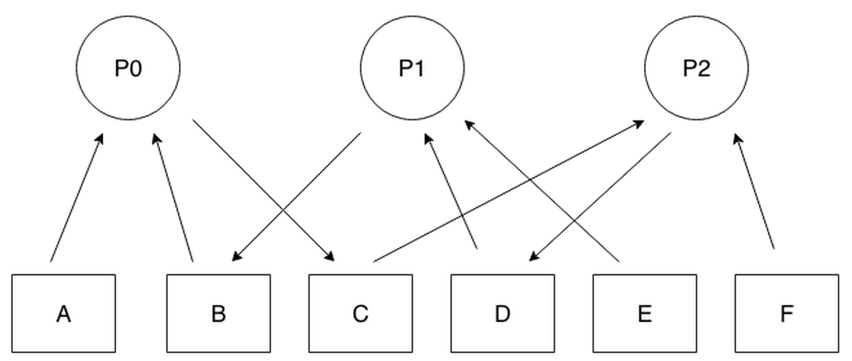  
a) Since all the process P0 is waiting for process P2 which itself is waiting for P1 which is waiting for P0, deadlock occurs due to cyclic waiting.

b)

Process P0-

get(B)

get(C)

get(A)

Process P1-

get(D)

get(E)

get(B)

Process P2-

get(F)

get(D)

get(C)

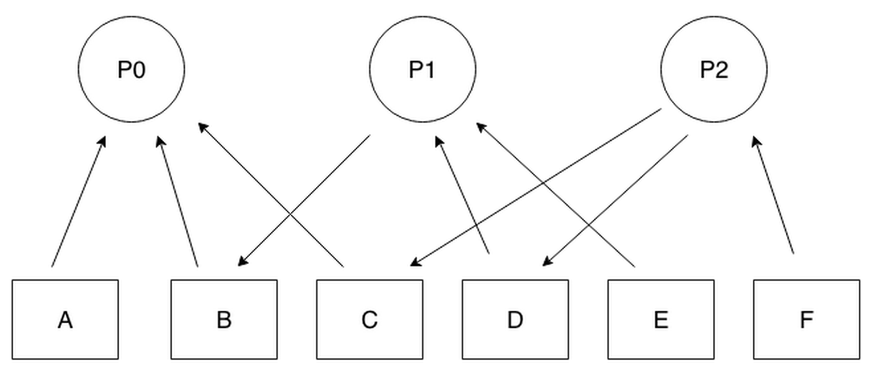

1. **Yes,** these processes can be blocked forever. **If statement 1 of bar() executes just after statement 1 of foo()** then both semaphores R and S would be 0 and would wait on statement 2 of bar() and foo().
2. Avoidance: Don't share resources across processes / mulitple threads

Prevention: When accessing shared resources, use a semaphore. If locking multiple semaphores, be sure to unlock in the reverse order of locking. Always be sure to handle errors within the critical sections so the semaphore is released under all conditions.

1. Yes, this system is deadlock-free. Proof by contradiction. Suppose the system is deadlocked. This implies that each process is holding one resource and is waiting for one more. Since there are three processes and four resources, one process must be able to obtain two resources. This process requires no more resources and, therefore it will return its resources when done.

RayShawn Ware

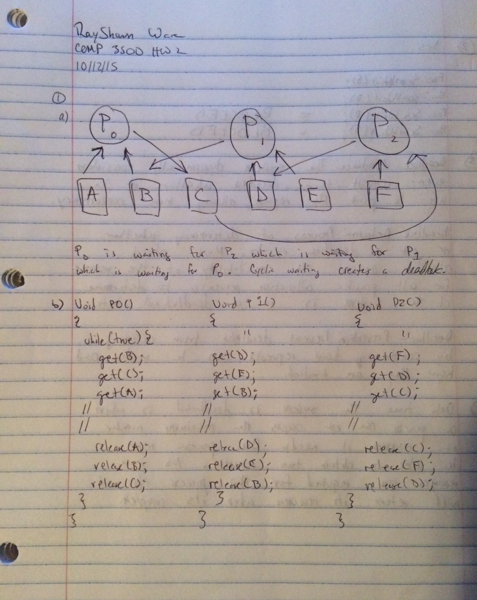

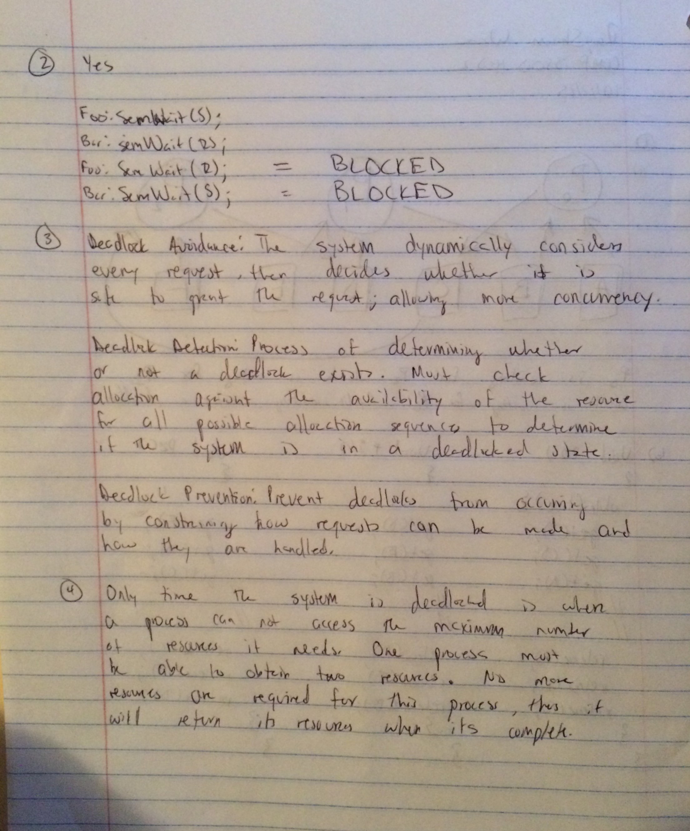

Bethany Edgar

COMP 3500

Homework 2

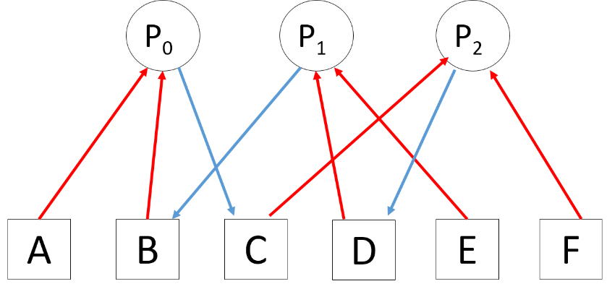

1. Assuming single instance resources, no preemption, and mutual exclusion (locks), this process exhibits hold and wait as well as circular wait. See simplified resource allocation graph featuring only the resources involved in deadlock below. Deadlock can occur.

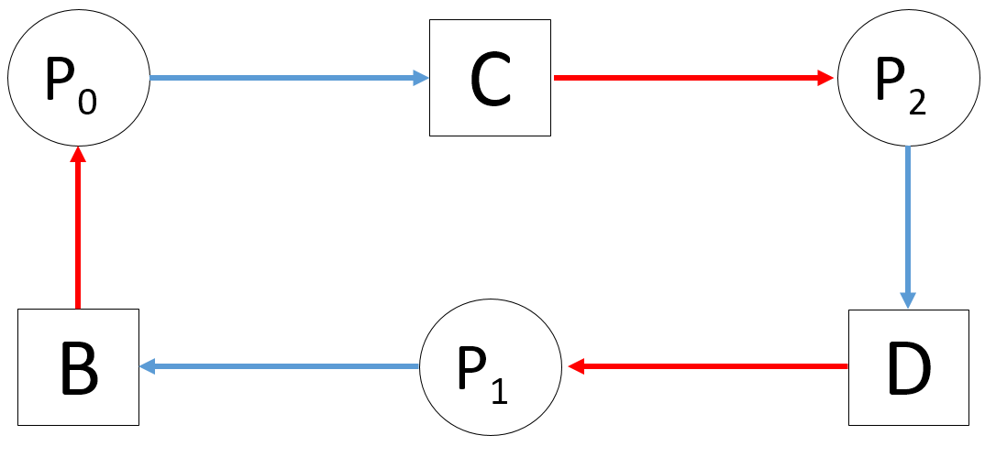

|  |  |  |
| --- | --- | --- |
| void P0()  {  while (true) {  get(A);  get(B);  get(C);  //critical region:  // use A, B, C  release(C);  release(B);  release(A);  signal(mutex);  signal(mutex);  }  } | void P1()  {  while (true) {  get(E);  wait(mutex);  get(D);  get(B);  //critical region:  // use E, D, B  release(B);  release(D);  release(E);  }  } | void P2()  {  while (true) {  get(F);  wait(mutex);  get(C);  get(D);  //critical region:  // use F, C, D  release(D);  release(C);  release(F);  }  } |

This imposes an ordering on the processes where P0 always goes first, then the circular wait is broken and P1 and P2 can execute concurrently since they both get unlocked by P0.

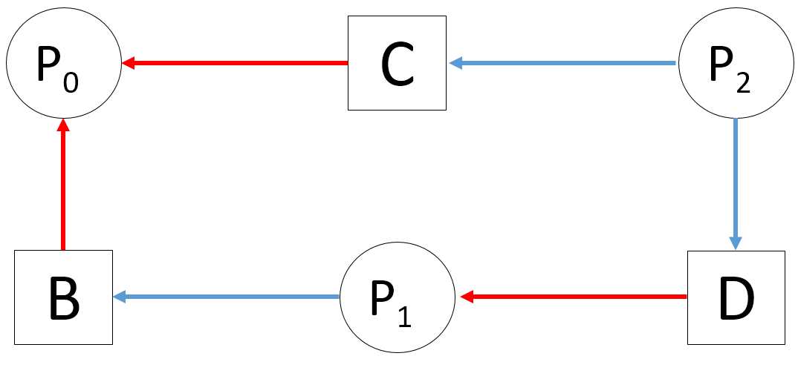

1. Yes, if the first line of foo executes and consumes the initial wait signal for S, then switches to the bar process and the initial signal to R is consumed. Now both R and S are waiting for signals that can never get sent as they cannot proceed to the later portion of the process.
2. Deadlock Avoidance: The avoidance technique deals with deadlocks dynamically, during the course of execution and is based on the current state of the process. Using this technique the system should never enter deadlock.

Deadlock Detection: Detection waits for a deadlock to occur, and then it breaks the deadlock by removing one of the four necessary conditions to create deadlock.

Deadlock Prevention: Deals with the code design process. It is coding to specifically eliminate any possibility of deadlock. This is static deadlock prevention.

1. If all hold one instance of the resource, and wait for another, then there will be one instance leftover (4-3=1). Then whichever process grabs the last instance first will complete and thus free up two instances. So then the last two processes can run concurrently. This could also be done in the opposite order, with two processes completing first then the remaining process finishing last.

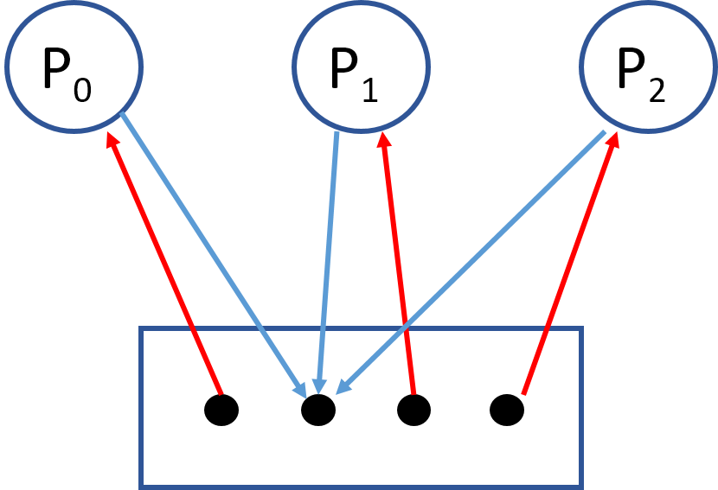

This illustrates that there is no circular wait as the instances of the single resource can be used interchangeably and there are more instances than there are processes.

**GROUP ANSWERS**

**Bethany Edgar**

1.



1. Assuming single instance resources, no preemption, and mutual exclusion (locks), this process exhibits hold and wait as well as circular wait. See simplified resource allocation graph featuring only the resources involved in deadlock below. Deadlock can occur.



|  |  |  |
| --- | --- | --- |
| void P0()  {  while (true) {  get(A);  get(B);  get(C);  //critical region:  // use A, B, C  release(C);  release(B);  release(A);  signal(mutex);  signal(mutex);  }  } | void P1()  {  while (true) {  get(E);  wait(mutex);  get(D);  get(B);  //critical region:  // use E, D, B  release(B);  release(D);  release(E);  }  } | void P2()  {  while (true) {  get(F);  wait(mutex);  get(C);  get(D);  //critical region:  // use F, C, D  release(D);  release(C);  release(F);  }  } |

This imposes an ordering on the processes where P0 always goes first, then the circular wait is broken and P1 and P2 can execute concurrently since they both get unlocked by P0.



**Bethany Edgar**

1. Yes, if the first line of foo executes and consumes the initial wait signal for S, then switches to the bar process and the initial signal to R is consumed. Now both R and S are waiting for signals that can never get sent as they cannot proceed to the later portion of the process.

**Bethany Edgar**

1. Deadlock Avoidance: The avoidance technique deals with deadlocks dynamically, during the course of execution and is based on the current state of the process. Using this technique the system should never enter deadlock.

Deadlock Detection: Detection waits for a deadlock to occur, and then it breaks the deadlock by removing one of the four necessary conditions to create deadlock.

Deadlock Prevention: Deals with the code design process. It is coding to specifically eliminate any possibility of deadlock. This is static deadlock prevention.

**Bethany Edgar**

1. If all hold one instance of the resource, and wait for another, then there will be one instance leftover (4-3=1). Then whichever process grabs the last instance first will complete and thus free up two instances. So then the last two processes can run concurrently. This could also be done in the opposite order, with two processes completing first then the remaining process finishing last.



This illustrates that there is no circular wait as the instances of the single resource can be used interchangeably and there are more instances than there are processes.